

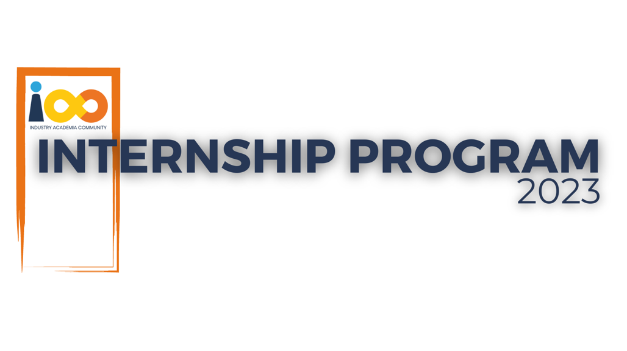

PROJECT REPORT

FULLSTACK DEVELOPMENT  
  
DEVELOP A WEB APPLICATION TO FIND THE RIGHT JOB AND INTERNSHIP

|  |  |  |  |
| --- | --- | --- | --- |
| **Created By:** | Chirag Yadav | **Approved By:** | Harshada Topale |
| **Created On:** | 17-07-2024 | **Approved On:** | 17-07-2024 |

Page left blank intentionally

**INDEX**

**1** **PROJECT DETAILS** 2

**2** **SUMMARY** 2

**3** **INTRODUCTION** 2

3.1 Background 2

3.2 Stakeholders 2

3.3 Objectives 2

**4** **METHODOLOGY** 2

4.1 Considerations & Assumption 3

4.2 Approach 3

4.3 Activities 3

**5** **TARGETTED V/S ACHIEVED OUTPUT** 3

**6** **CONCLUSION** 3

**7** **APPENDICES** 4

7.1 Appendix A – Title 4

**General Instructions for using the Live Project Report Template**

* This template and the subsequent document created using this template is a confidential document and is the intellectual property of Cloud Counselage Pvt. Ltd. Circulating it outside of the organisation without the consent of Cloud Counselage Pvt. Ltd. is the breach of company policies and will lead to legal actions
* This template is a guideline document to communicate the implementation of design ideas and the results of the work to the stakeholders.
* The **text between inequality (< >) is to be replaced** by relevant text
* Please **remove the yellow highlight on the Text** between the inequality (< >). This is done to help you notice the text to be changed/replaced
* The text in *italics* highlighted in grey is just for reference and should be removed after adding the relevant text

# **PROJECT DETAILS**

|  |  |  |  |
| --- | --- | --- | --- |
| **Project Name** | Develop a Web Application to Find the Right Jobs and Internships | | |
| **Project Sponsor** | Harshada Topale, Tushar Topale | | |
| **Project Manager** | Harshada Topale, Tushar Topale | | |
| **Start Date** | 17-07-2024 | **Completion Date** | 20-09-2024 |

# **SUMMARY**

*The project, "Develop a Web Application to Find the Right Jobs and Internships," aimed to deliver a platform that simplifies the job search process for users, especially students and fresh graduates. The application was developed to address the challenges of finding relevant opportunities in a competitive job market by offering a tailored and user-friendly interface. The long-term benefits include increased accessibility to job and internship opportunities, better decision-making through advanced filtering and recommendation systems, and enhanced efficiency for recruiters to identify suitable candidates. This application is expected to bridge the gap between job seekers and employers effectively.*

# **INTRODUCTION**

## Background

*In today’s fast-paced and competitive job market, students and fresh graduates often struggle to find internships and entry-level positions that align with their skills and interests. Existing platforms are often cluttered, lack personalization, and fail to meet the specific needs of their users. This project was initiated to develop a web application that resolves these pain points by providing a seamless and intuitive platform for job and internship searches. The idea was conceived during requirement elicitation meetings, where stakeholders expressed the need for a user-centric solution that leverages modern web technologies.*

## Stakeholders

*The key stakeholders identified for the project are:*

* ***Job Seekers:*** *Students, fresh graduates, and professionals looking for internships or full-time positions.*
* ***Recruiters/Employers:*** *Organizations seeking to hire suitable candidates for internships or entry-level roles.*
* ***Educational Institutions:*** *Universities and colleges that aim to assist their students in finding relevant opportunities.*
* ***Development Team:*** *The group responsible for designing, building, and maintaining the application.*

## Objectives

*The primary objectives of this project were:*

*To create a platform that allows users to search for jobs and internships with advanced filtering options.*

*To provide a personalized experience by recommending opportunities based on user profiles and preferences.*

*To simplify the application process for users and enhance recruiter efficiency through optimized tools.*

*To ensure the application is scalable, secure, and responsive across devices.*

# **METHODOLOGY**

These conventions are all about the positions of line breaks, how many characters should go on a line, and everything in between.

## Considerations & Assumption

*Constraints: Limited development timeline and resources.*

*Challenges: Ensuring the application remains responsive across devices and implementing an effective recommendation algorithm.*

*Assumptions: Users would provide accurate information in their profiles, and recruiters would actively post opportunities.*

## Approach

*Requirement Analysis: Understanding stakeholder needs.*

*Design: Wireframing and prototyping the user interface.*

*Development: Building the frontend using React and the backend with Node.js, Express, and MongoDB.*

*Testing: Conducting unit, integration, and user acceptance testing.*

*Deployment: Hosting the application on a cloud-based platform.*

## Activities

*Requirement Gathering: Conducted stakeholder interviews and surveys to identify pain points and desired features.*

*Planning: Created a project timeline and defined milestones.*

*Designing: Developed wireframes and mockups to visualize the user interface.*

*Implementation: Built and integrated the frontend and backend components.*

*Testing: Conducted rigorous testing to identify and fix bugs.*

*Deployment: Deployed the application on a cloud hosting platform.*

# **TARGETTED V/S ACHIEVED OUTPUT**

*<*

|  |  |  |
| --- | --- | --- |
| Targeted Output | Achieved Output | Reason |
| Advanced filtering for jobs and internships | Successfully implemented filtering by skills, location, and preferences. |  |
| Personalized job recommendations | Implemented a recommendation engine based on user profiles and activity. | Minor adjustments due to data availability constraints. |
| Responsive design | Delivered a fully responsive design tested across various devices. |  |
| Seamless application process | Created a streamlined process with resume uploads and tracking capabilities. |  |

# **CONCLUSION**

*This web application addresses the significant challenges faced by job seekers and recruiters in finding and posting opportunities. By leveraging modern web technologies, the application ensures a user-friendly experience, advanced filtering options, and efficient communication tools.*

*Future Scope:*

*Integration with external job boards for a broader range of opportunities.*

*Implementation of AI-based resume scoring to help users improve their applications.*

*Expansion to include global job opportunities.*

# **APPENDICES**

## Appendix A – Title

Login

Register

Jobs

MailIconComonent

Profile

RequestsPage

SearchComponent

Home

NotFound

UserProfile